FIRE PROCEDURES
Please ensure you have a Register of names for your group and bring this to the assembly point if there is an evacuation.
We would appreciate if you would take some time to acquaint yourself with the emergency procedures in the building.
In the event of a fire the alarm sounds continuously. Please leave the building by the nearest emergency exit which is clearly marked and go to the assembly point shown below.
Do not use the Lift! Do not stop to collect personal belongings and do not re-enter the building until told to do so by a member of staff.
There is a Disabled Refuge at the top of each stairwell for those who find the stairs difficult or have mobility issues. If you find yourself in this position, you should press the green button and remain at the refuge until escorted out by staff or the Fire Brigade.
The Fire alarm is tested every Friday at 8.30am by sounding of the alarm and only continuous ringing signifies that the building should be evacuated.
ANY PERSON DISCOVERING A FIRE
- BREAK GLASS ON THE NEAREST ALARM CALL POINT
- CENTRE STAFF WILL CALL THE FIRE BRIGADE
- IF IT IS SAFE TO DO SO ATTACK THE FIRE WITH A SUITABLE APPLIANCE
ON HEARING THE FIRE ALARM
- LEAVE THE BUILDING BY THE NEAREST EMERGENCY EXIT
- CLOSE ALL DOORS & WINDOWS BEHIND YOU
- REPORT TO THE ASSEMBLY POINT
ASSEMBLY POINT – OPPOSITE VIEWFIELD DR ENTRANCE see photos below:
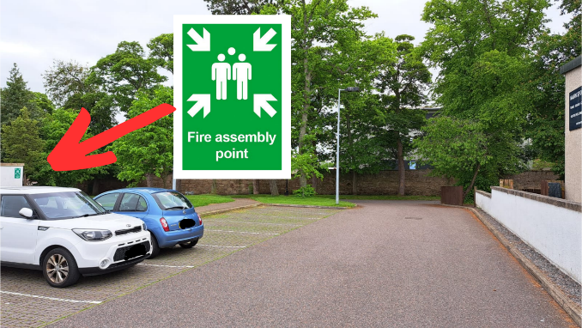
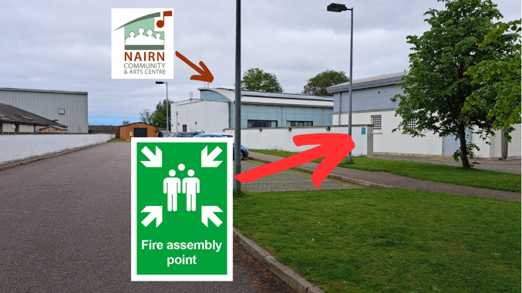

OR AT THE BOTTOM OF THE STEPS FOR THOSE EXITING THROUGH YOUTH CAFÉ FIRE EXIT (WHICH IS ADJACENT TO A96).

..................................... Tear Off Strip ..............................................
Please sign and return to a member of staff.
I have read and understood the fire procedures for Nairn Community Centre
Signature..................................... Print Name.......................................................
User Group...................................... Date..................................

