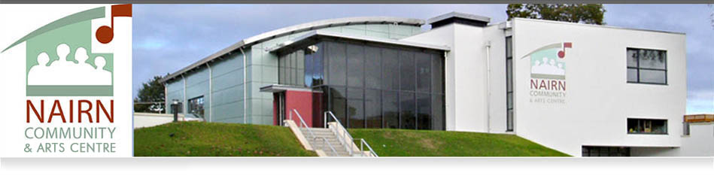
NOTICE OF ANNUAL GENERAL MEETING
Notice is hereby given that the Annual General Meeting of Nairn Community & Arts Centre will be held at 7.00pm for 7.30pm on 6th December 2024 at Nairn Community & Arts Centre, King Street, Nairn for the purposes below.
Agenda
- Welcome
- Apologies
- Presentation of the directors’ report and statement of accounts for the year ended 31st March 2024
- Resolutions (see below)
- Update on Centre activities and the future
- Invitation for attendees to contribute
- Any other business
Resolutions
The AGM will be held to consider and, if thought fit, to pass the following resolutions:
- Appointment of Directors (ordinary resolution)
All the current directors are to retire at this AGM. The following are agreeable to be reappointed, namely: Robert Ferenth, Michael J Mitchell, Alastair G M Forsyth and Peter D Saggers.

- Amendment to Nairn Community & Arts Centre Articles (special resolution)
Reinstatement of Powers of Company, wrongly omitted in revised Articles dated December 2022 under new section 4 and inclusion of new section 5 on Restrictions on use of Company’s Assets.
Signed

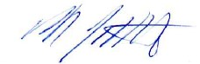

Michael J Mitchell CA
Director/Company Secretary

