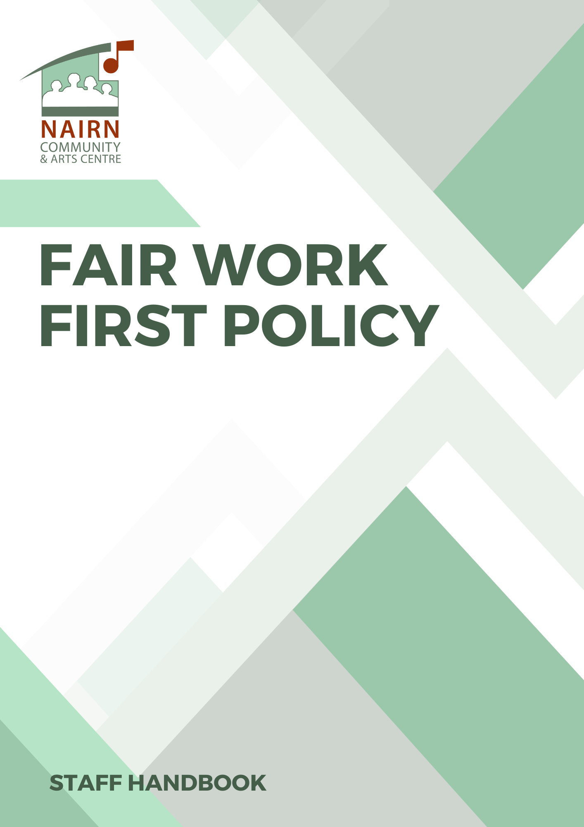
FAIR WORK FIRST POLICY

NAIRN COMMUNITY AND ARTS CENTRE (NCAC) care about the well-being of our staff and creatives that we engage with, and we want to see them flourish. We are committed to advancing the Fair Work First criteria as set out within the Scottish Government guidance document.

We are a “values-led” charity and by investing into our staff personal development, it allows them to bring fresh ways of thinking, new models of working, build their confidence and networks to benefit both their own career and our organisation.

We have appropriate channels for effective voice from the workforce:
- NCAC supports the development of a working environment where there is space for people to be heard and where people can be who they are and can have a choice and participate. We promote a strong culture of openness and encourage acceptance of different viewpoints through our regular in person meetings. This is demonstrated through monthly staff meetings enabling staff to raise and discuss any issues. Weekly staff meetings involve the planning of the week ahead and the staff required for the smooth running of the Centre – at which there is always the opportunity for open discussion. The Centre Manager holds an ‘open door’ policy, and all employees are encouraged to discuss any issues without fear of judgement, offering a ‘safe space’ to talk and discuss any matters, grievances, or concerns within the workplace.
- NCAC supports the five Dimensions of Fair Work.
- Effective voice
- Security
- Opportunity
- Fulfilment
- Respect

We actively invest in workforce development:
- NCAC supports learning and development across the charity at individual and team level using a range of learning opportunities. NCAC expects the Centre Manager and employees to proactively engage in career performance and development planning conversations regularly.
- We are committed to being a transparent and “Equal Opportunities” Employer with appropriate and clear routes for resolving issues in our staff handbook.
- As part of our staff handbook documentation, we have a “Code of Conduct” with 5 guiding principles.
- Be considerate and respectful to all.
- Choose your words carefully.
- Be inclusive.
- Always think about confidentiality - of your colleagues, audience members and creatives working within NCAC.
- Make challenges into opportunities.

We are committed to no inappropriate use of zero hours contracts:
- NCAC does not operate, and will not operate in the future, the use of zero hours contracts.

We take action to tackle the gender pay gap and create a more diverse and inclusive workplace:
- NCAC is fully committed to an inclusive culture that welcomes all people for who they are. The pay scale bands are the same for all employees irrespective of their gender.

We are fully committed to paying the real Living Wage to both our employees and ensuring our contractors (where appropriate) also do the same.
- The lowest paid posts and their pay scale reflect the 2024 real Living Wage rate.

This statement has been agreed by both the employer and workforce representative from the employees:

Signature (for the employer):



Print name: MICHAEL J. MITCHELL

Position: DIRECTOR

Signature (as workforce representative)

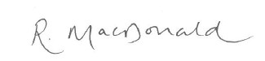

Print name: RHONA MACDONALD

Position: CENTRE MANAGER

